**Health care News (Project)**

1. Admin View
2. User View
3. All View
4. Admin View

* Users
* Roles
* Categories
* News
* Ads

Users

* Create
* Retrieve
* Update
* Delete

Roles

* Create
* Retrieve
* Update
* Delete

Categories

* Create
* Retrieve
* Update
* Delete

News

* Create
* Retrieve
* Update
* Delete

Ads

* Create
* Retrieve
* Update
* Delete

News

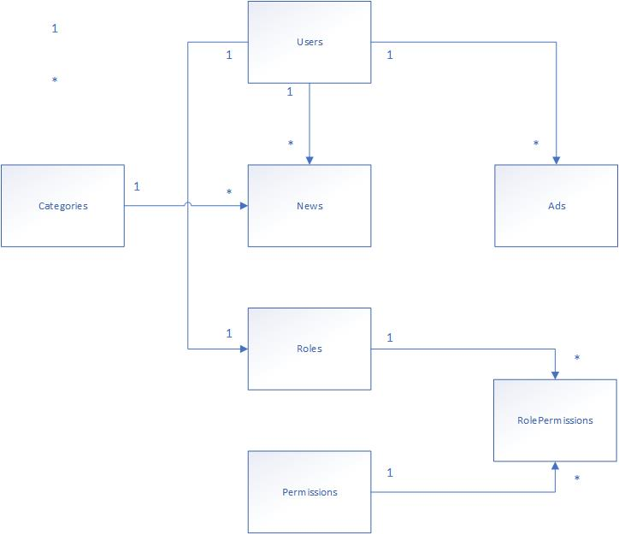

**Register**

**Login**

**Ads**

**Search**

**News**

When Url Enter,

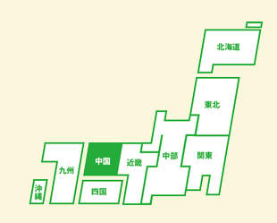

User News

**Search Combo**

­

**Search**

**User News (Search Result)**

**Ads**

**Related News**

When Click details,

News Details

Related News

**Login for Admins and Users**

Login

Email

Password

LOGIN

Forget Password

**When Admin Login,**

Admin Dashboard

**Search Box**

Search Post List

News Post

Users

Categories

Ads

Logout

Results

Results

Results

Results

Results

**menus**

**Delete**

**Delete**

**Delete**

**Edit**

**Delete**

**Delete**

* Post Details

**When click News Post,**

**Search**

**News Post**

**Users**

**Categories**

**Ads**

**Logout**

**News Body**

**Category**

**Title**

**Browse**

Image Here

**Post News**

Create New Post

Create New Post

**menus**

**menus**

Image

* Table fields

**When click Users,**

**Search**

**News Post**

**Users**

**Categories**

**Ads**

**Logout**

**Delete**

**Confirm**

**Create New User**

User List

User List

Search Box here

**menus**

User List Table

* When click confirm, confirmation mail send to user.

**When click Categories,**

**Search**

**News Post**

**Users**

**Categories**

**Ads**

**Logout**

**Edit**

**Delete**

**Create New Category**

Categories List

Search Box here

Categories List Table

**For Ads,**

**Ads**

**User Register**

Register

Company Name :

Type :

**Browse**

Logo :

Email :

Password :

Confirm Password :

Phone :

Address :

**Cancel**

**Register**

* **After register, wait for admin confirmation mail.**

**When user Login,**

Search Post List

News Post

Profile

Logout

Results

Results

Results

Results

Results

User Dashboard

Search Box

menus

**Delete**

**Delete**

**Delete**

**Edit**

**Delete**

**Delete**

**When user click News Post,**

**Search**

**News Post**

**Profile**

**Logout**

**News Body**

**Category**

**Title**

**Browse**

Image Here

**Post News**

Create New Post

menus

**When user click Profile,**

**Edit**

Profile

Company Name :

Type :

Logo :

Email :

Password :

Confirm Password :

Phone :

Address :

Motto :

**Edit Profile,**

Profile Edit

Company Name :

Type :

**Browse**

Logo :

Email :

Password :

Confirm Password :

Phone :

Address :

Motto :

Cancel

Update

Language : PHP 7+

Database : MariaDB – 10.3.16

Framework : Laravel (or) JS Framework + api

index

Create_user

User list

Create category/edit

Category list

Create news/edit

News list

News details

Login

Register

Profile

Profile edit

Index / layout – ma WHO

Admin/user/layout – TZ

News list (search), login – kyl

User register/profile edit – zk

Profile view – ptz

News create / admin / user – atdk

News details – mpks

User list / categories list -